



**John D. Rockefeller (1839-1937)**

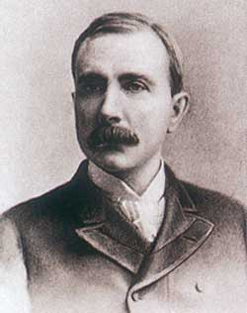**Background**: John D. Rockefeller was born to a poor family in Cleveland, Ohio. As a youngster, Rockefeller’s father would disappear for months at a time so he was forced to work from a very young age to support the household.

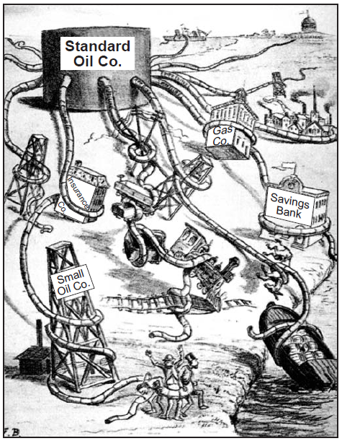

**Eliminating Competition**: After acquiring his first oil refinery at age 26, John D. Rockefeller decided to wipe out all of his competition. First, Rockefeller slashed his prices and forced competing oil refineries out of business. Secondly, by using vertical integration, Rockefeller was able to save huge amounts of money. Standard Oil owned everything they needed including a forest to make wooden barrels and buildings from. By doing this, Rockefeller could lower his prices even further until his competitors had no business left. Thirdly, Rockefeller was able to pressure the railroads to give him lower rates to ship his oil. Lastly, Rockefeller obtained stock in rival oil companies. Because he owned a majority of stock in a rival company, he could make decisions that would benefit Standard Oil. This is kind of like being the coach of your rival team and throwing the game on purpose. By 1888 Rockefeller’s Standard Oil Trust controlled 95% of the nation’s oil.

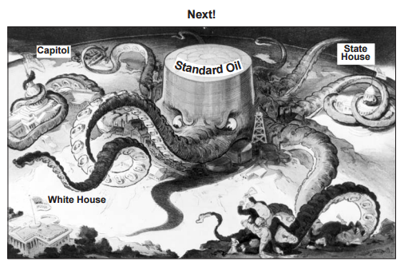

**Philanthropy**: Rockefeller, like many of his millionaire peers, grew interested in philanthropy (the use of money to benefit the community). Rockefeller felt that it was his duty to give vast amounts of money to build schools, universities, hospitals and especially medical research facilities. Rockefeller used his money to establish the University of Chicago and also the Rockefeller Institute for Medical Research. Altogether, it is believed that Rockefeller donated more than $500 million of his fortune to charity.

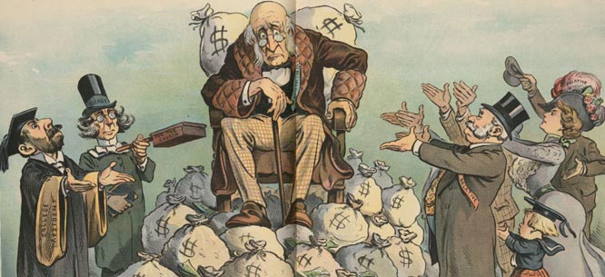

**Andrew Carnegie (1835-1919)**

Scanned portrait 
photograph of Andrew Carnegie.

**Background**: Andrew Carnegie was 12 when his family moved from Scotland to Pennsylvania in search of work. Carnegie’s first job was in a cotton mill at the age of 13. Later, he worked in a telegraph office and on the railroad to help support the family.

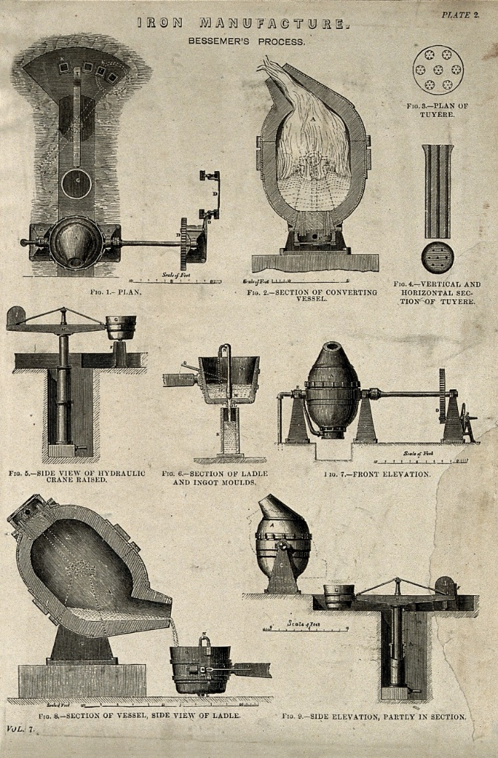**Ending Competition**: While Carnegie was traveling in England in 1870, he learned a quick and cheap way to make steel called the *Bessemer Process*. When he returned to the United States, he built a steel mill and began producing low-priced, quality steel. With his profits, he began to buy out his rivals in the steel industry. The second step to eliminating the competition came when Carnegie began to buy iron mines, railroad and steamship lines, and warehouses. Soon, Carnegie controlled all phases of the steel industry—from mining the iron ore to shipping the finished steel. *Vertical Integration*, as it was called, meant that he did not have to deal with anyone else and that saved him vast amounts of money. By 1900, Carnegie Steel was turning out more steel than all of Great Britain—the strongest country in the world at the time.

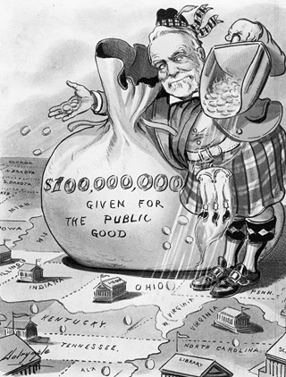

**Philanthropy**: Carnegie also believed that the rich had a duty to improve society. All told he donated over $400 million to charities and organizations. He gave $60 million to improve and build 4,000 public libraries all over the country. He built Carnegie Hall in New York City, Carnegie-Mellon University in Pittsburgh, and the Carnegie Foundation for the Advancement of Teaching. Carnegie was known to have said “I was born a poor man, and I intend to die that way as well.” Before his death he said “…a man who dies rich, dies disgraced.”

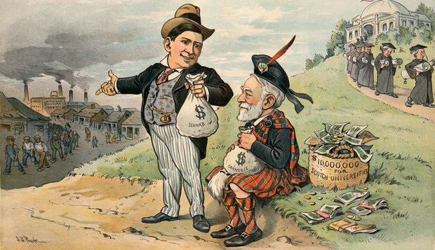

**J.P. Morgan (1837-1913)**

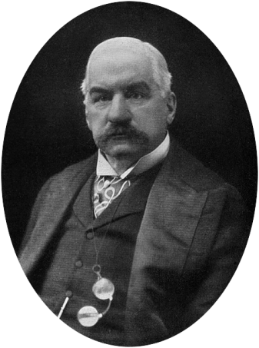

**Background**: John Pierpont Morgan was born and raised in Hartford Connecticut to a wealthy banking family. Unlike Carnegie and Rockefeller, Morgan was able to be sent to the best schools and travel the world as a boy.

**Ending Competition**: J.P. Morgan grew to be one of the most influential men in American business by combining smaller companies into huge monopolies. Using loans from his banks, Morgan gained control of many corporations throughout the world. Morgan was able to loan money to the biggest electric companies and combine them into the business we know today as General Electric. Morgan also was able to buy Carnegie Steel from Andrew Carnegie and combine it with the many Railroad firms he had acquired and turn it into U.S. Steel, the first billion-dollar business in history.

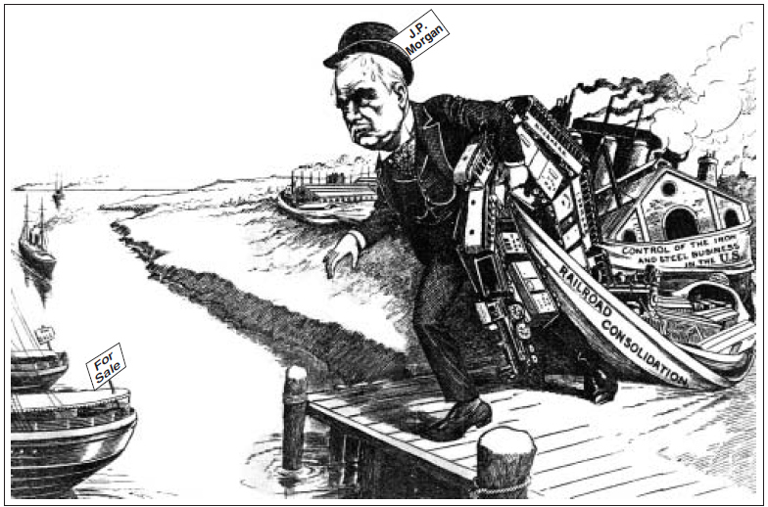

**Philanthropy**: J.P. Morgan’s donations to charity are a little different from the other business titans of the late 1800’s. Morgan was a passionate art collector and he funded hundreds of museums and donated priceless works of art to many of them. Morgan also was in a position to “bail out” the Federal Government more than once. In the early 1890’s he donated over 2 million ounces of gold to our financially strapped government and in 1907 he loaned the government $35 million so they could keep the stock market from crashing.

